**Brooklyn torah gazette**

**For parshas vayeira 5782**

Volume 6, Issue 5 (Whole Number 260) 17 Cheshvon 5782/ October 23, 2021

**Printed L’illuy nishmas Nechama bas R’ Noach, a”h**

For a free subscription, please forward your request to [***keren18@juno.com***](mailto:keren18@juno.com)

**A Brother’s Story**

**By Gerald Brody**

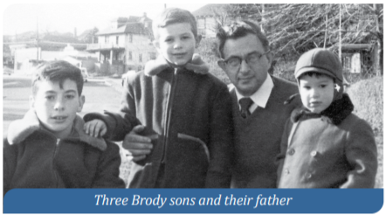

*Dear Reader: People frequently reach out to HFBA, looking for lost relatives from generations ago. We research our archival records and provide information when we can. Often people will share moving stories with us about their families and loved ones. This spring, we received the letter below from Gerald Brody. I was deeply moved by his dream of finding the grave of his lost sister and recovering her place in the Brody family. How gratifying it is to know that she is not forgotten. HFBA Director of Operations Andrew Parver responded to Gerald’s call and photographed the gravesite. Our staff will help Gerald when he and his wife visit the cemetery. HFBA will continue to maintain Baby Girl Brody’s gravesite with dignity and respect. -* ***Amy Koplow, Executive Director of the Hebrew Free Burial Association***

I’ll be visiting my sister’s grave soon for the first time. I’m 70 and she was stillborn seventy-five years ago, on December 6, 1945, in Manhattan.

*“She’s buried in the Mt. Richmond Cemetery at 420 Clarke Avenue in Staten Island in section 28, row 4, graves 28-29. You get to Mt. Richmond by taking the ferry, making a left onto Bay Street, then a series of rights and lefts until you get to Clarke, which is where the cemetery is.”*

Those instructions are from 1945, on a card given to my father when he buried his daughter. He kept it. By phone, I spoke to a man from the organization, Hebrew Free Burial, which owns and operates the cemetery, and asked him for a picture of my sister’s grave. He asked me where in the very large cemetery she was buried. I told him. I heard some voices in the background and then he put me on hold. There was no “musak.”

About a minute later he came back and said that I should send the association an email with the specific information about the grave and how I could be contacted. He said that he would get me the photo. This is all happening 75 years later because I had not been able to find her grave before.

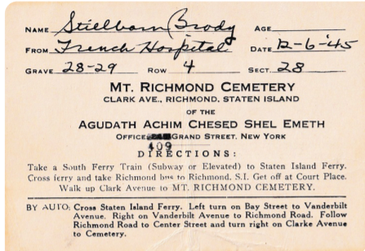

I knew that death certificates were issued for stillborn babies. You can get old death certificates for a small fee, but you have to request them by borough. I knew she was buried in Staten Island. My parents had lived in the Bronx and my mother had given birth in Manhattan. I sent requests to all three boroughs. Twice. Apparently for deaths from that long ago, they have to do a manual search. I was told they couldn’t find it. Six times. I had given up hope of ever finding her grave. Sometimes I thought that maybe she was never buried at all and was thrown out in the hospital garbage, that my parents had made up the story of the burial because they didn’t know what else to say.

I found the card with information about the burial when I was looking for family history to give to my 17-month-old granddaughter, Larkin. If I didn’t do this now, she will never get to know this stuff. It will be lost. I remembered there was a box labeled “very old pictures and papers” in the back of a closet. I don’t know how I got the box and have no memory of taking it from house to house as I moved over the years, but there it was. Hundreds of pictures and dozens of documents.

In the pile was a 3-inch by 5-inch yellowing post card with some Hebrew writing on it. I don’t read Hebrew. I was about to toss it into the “not interested” pile but turned it over first. And there it was. The burial information for a “stillborn Brody” baby. They hadn’t named her I just looked at it for a long time. A very long time. I was stunned. This was something I was sure would never happen.

I didn’t cry until later, until I broke down telling my wife, Pat, the story. “We’ll visit the grave together soon,” she said. I was sobbing and it was very quiet, except for my gasps. I have always thought of my family as my parents and three boys. I had known about my sister, but she wasn’t real to me. Now we are a family of four children, three brothers and one sister and I know now where she is.

*Reprinted from the Elul 5781/Rosh Hashana 2021 edition of Chesed, a quarterly publication of The Hebrew Free Burial Association.*

**Thoughts that Count**

Thus, the angels, as representatives of the entire world, came to visit Avraham in whose merit the world was created.

"And he said, my L-rd, if I have found favor in your eyes, pass not away from your servant." (Gen. 18:3)

According to the Talmud (Shabbat 127a), Avraham was speaking to G-d and asked Him to wait until he brought the guests into his home; for the mitzva of welcoming guests and taking care of their needs is greater than kabalat penei haShechina--welcoming G-d. *(Yalkut HaDrush as quoted in Vedibarta Bam)*

*Reprinted from Reprinted from the 5756/1996 Vayeira edition of L’Chaim Weekly.*

**Parshas Va’Yairah:**

**The Love of Chessed**

**By Rabbi Bentzion Shafier**

**Founder of TheSmuz.com**

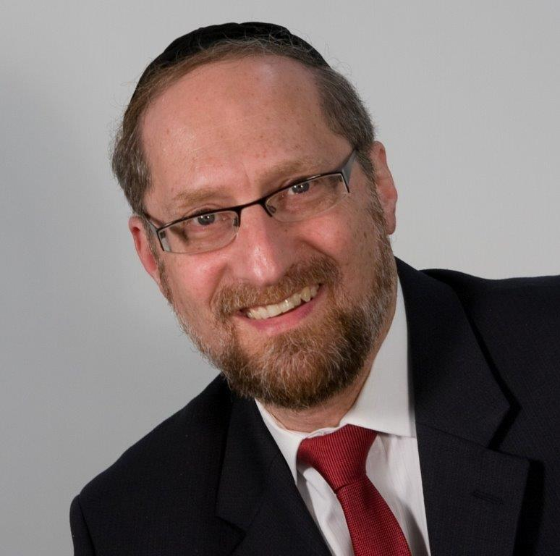

“*And to the cattle Avrohom ran, and he took a young calf, soft and good, and he gave it to the lad, and he hurried to prepare it*.” — Bereishis 18:7

Parshas Vayaira opens with a detailed description of a day in the life of Avrohom Avinu. Avrohom was 99 years old, and it was the third day after his undergoing the bris milah. He was in such pain that HASHEM changed the course of nature in order to protect him. On a typical day, Avrohom would spend much time and effort waiting on guests. Out of concern for Avrohom’s condition, HASHEM took the sun out of its normal course, making it unusually hot, so that there would be no travelers to trouble Avrohom.

However, if it could be, Avrohom befuddled HASHEM. As he sat there in his tent, he had more pain from not being able to serve guests than he would have had if he had been running around after them. Therefore, HASHEM sent three angels in the form of men to allow Avrohom to serve them as guests.

When Avrohom saw three men standing on the horizon, he ran out and bowed down to them, full face in the sand. He said, “Please do not pass by from me, your humble servant.” He then brought them back to his tent and ran to prepare food and drink for them. He ran to his cattle, took a “young calf, soft and good,” and had it prepared for them. He then stood over them while they ate.

**A Young, Soft and Good Cow**

As every word in the Torah has a specific purpose, Rashi is bothered by why the Torah deems it important to record three adjectives: “**young**,” “**soft**,” and “**good,”** when it describes the cow that Avrohom brought. He explains that this teaches us that Avrohom prepared three separate cows because he wanted to serve a tongue to each of his guests.

The Siftei Chachamim explains that the tongue has three sections. The tip is soft, the middle is fatty, and the back has varied textures. Avrohom wanted to be certain that there would be enough of each section so that each guest could eat as much as he liked, even if all three guests preferred the same section. To do that, he had to slaughter three cows to insure that that there would be enough of each part.

It wasn’t enough that he offered them a meal without expecting anything in return. And it still wasn’t enough that he served them himself. Standing over them in the heat of the day, he went to the great expense and bother of slaughtering three entire cows so that his honored guests would have only the best.

Didn’t Avrohom Avinu have better things to do with his time?

While this is a beautiful recording of the chessed of Avrohom, it begs a question: didn’t Avrohom Avinu have better things to do with his time?

At this point in his life, Avrohom was a great and wealthy man. He had hundreds of servants and an entourage of thousands of students and converts. No doubt, he had many important things to do, not the least of which was to teach his many, many students.

Yet Avrohom Avinu stopped everything that he was doing, went to great efforts and spared no expense to serve them. Why did he stop his busy day just to take care of three regular people? We know that doing chessed is a wonderful thing, but it seems that this is a bit out of proportion. Why did Avrohom Avinu put so much emphasis on chessed, and why does the Torah record this in such great detail?

**The Significance of Chessed**

The answer to this question is based on understanding what it is that HASHEM wants from man.

HASHEM is the Giver and wants to give of his good to man. HASHEM put us on the planet so that we can earn our reward in the World to Come — the ultimate good for man. There we can enjoy HASHEM’s presence, there we can bask in His glory, and there we can enjoy the ultimate happiness that man can experience.

That state of eternal bliss is achieved by being close to HASHEM. The closer a person is to HASHEM, the greater the joy and pleasure he can experience. A person becomes close to HASHEM by making himself like HASHEM as much as he can. All the mitzvahs of the Torah guide a person towards that level of self-perfection.

**Avrohom was Emulating HASHEM**

Avrohom spent his life emulating HASHEM. Every waking moment of his existence was focused on making himself as much like HASHEM as humanly possible. From the time that he came to recognize HASHEM, he understood the loving kindness with which HASHEM created the world and continues to run it. Avrohom saw that the essence of all of HASHEM’s interactions with this world is chessed, so he set it as his goal in life to imitate HASHEM by doing for others as much as he could. As a result, chessed was the center point of his service to HASHEM and the focus of his life.

This seems to be the answer to the question on Rashi. Despite the fact that his servants could have taken care of his guests’ needs just as easily as he, Avrohom threw himself into this act with his whole heart. Just as HASHEM provides sustenance for every living creature, Avrohom was in his small part providing for the needs of others. This wasn’t something that could be just as easily done by someone else; this was pivotal towards his purpose in existence — because by doing this he was acting like HASHEM.

**A Lesson to Us**

This concept is a powerful illustration of the importance of helping others. When we see one of the greatest human beings who ever lived involved in what seems to be the most mundane of tasks, it demonstrates to us the significance of those deeds. By focusing on this, we will come to appreciate that Avrohom was engaged in the ultimate perfection of the human, the highest level that a person can function on. More than fulfilling a mitzvah, chessed is our way of being like HASHEM, the very reason we were put into this world.

*Reprinted from the current website of TheShmuz.com*

# Rav Avigdor Miller

# On Pollution and

# Government Spending



**QUESTION: Should people worry about things like pollution and over population and so on or should they leave it to Hashem?**

**ANSWER:** The whole business is one huge bluff.  Anybody who talks about this subject, anybody who preaches the subject of antipollution, even if he doesn’t mean that there are too many people in the world, you have to suspect that he’s a faker, a pseudo-liberal; he’s a show-off, an insincere fellow, a fellow who lives with artificial ideas who is trying to make himself what he isn’t. He’s just mimicking the words of the degenerates of the New York Times.

There are so many issues to worry about. Why don’t they worry about crime on the street? These crooks who talk about about zero population growth, the college professors who teach it – they teach it, preach it – why don’t they preach about doing something to punish criminals?

Why don’t they preach the necessity of stiffer sentences?  Now, they have all one standard retort but it’s a lie.  They say that repression, stern punishment, never accomplishes anything. And that’s a plain lie because all of us can remember thirty years ago when we could walk the streets.  We could walk even through the black neighborhoods at night.  Thirty years ago, I used to walk every night through black neighborhoods.  It didn’t enter my mind to be afraid.

And it was because of one simple reason. It was because everybody knew that the policeman could come with a stick and give a bang over the head. Mayor Lindsay wasn’t around yet with his Civilian Review Board.  It’s when the Lindsays came along and they emasculated the police, when they frightened and intimidated the police, and the judges became liberals – the judges saw where the wind was blowing and they also were intimidated – that’s when crime began.

**The Issue of Immorality is**

**Corroding the Entire Country**

And therefore, these criminals who don’t talk about the real issues that face us – that’s the issue of crime – they’re the real trouble. I’m not even talking about the issue of degeneration, of immorality, that’s corroding the entire country.  The wickedness of homosexualism, the wickedness of promiscuity and the wickedness of drug liberalism. It’s in all the colleges.

All these great problems are left alone.  What problems are dealt with?  Zero population. How to kill more and more babies.  And that’s what they’re doing in the hospitals.  In the hospitals when someone comes for an abortion, so sometimes they arrive just too late.  The baby is already out.  But the doctor is kindhearted anyhow.  So, he tells the porter who’s standing there, “Put it in a bucket of water.”  It happened. Had she come a minute before, there would have been an abortion.  She came a minute too late.

As the doctor applied the suction pump, a live baby came out too quickly and it was yelling.  He wants to live.  So instead of giving him the treatment that you give newborn babies, he told the porter – there happened to be a colored porter who was standing there – he told the colored porter, “Dunk it in the water.”

The colored porter said, “I’m not a professor.  I’m not hired to kill babies.” “I’m not hired to kill babies,” he said.  That’s the good sense of a colored porter. But it’s not the sense of a college professor.  So, it’s these degenerates, they’re the ones who are worried about the ecology and pollution!

**Getting Rid of the Pollution of Crime**

Should we leave it to Hashem?  No. It’s up to us to worry about all good and sensible things.  So, let’s first worry about getting rid of the pollution of crime; and while we’re at it, let’s get rid of the pollution of the colleges.  If we could stop government subsidies for colleges and make it necessary to pay tuition so bums couldn’t go; only working people who paid their way or rich people who could afford it.  So, you clean out the scum from the colleges.

And of course, there would be a smaller tax burden on the decent citizens.  This government spending is a cancer.  The government is throwing out money recklessly for every silly thing.  Every silly cause is getting millions.  Even the “Golden Age Clubs,” the programs for the elderly. You need them like a hole in the head.  The government is throwing away millions so that old people get together in the mornings.  Instead of staying home and taking care of their homes, they get together. And the synagogues and the churches are reaping a golden harvest.  They’re teaching old people how to dance; men and women, eishes ish.  Dance with another man’s wife. They never knew it before.  Now they’re learning it in their old age.  That’s a wonderful thing.  And all this costs millions.  Here’s pollution for you! Government spending!

Even if a fraction of it went to reinforce our arms! You know that we’re falling behind in the arms race?  The liberals are preaching that we should disarm; in this country we’re disarming.  But not in Soviet Russia.  Soviet Russia now is far ahead of us. The best argument for peace is to be well armed.  You remember the adage, “Carry a big stick and talk softly.”

But we don’t have a big stick anymore.  The liberals have disarmed America.  The liberals have taken the money in America and are pouring it in every useless cause. And the poor sucker, the American citizen, is paying and paying.  And that’s why accounting has become the most brilliant future for young men today. And that’s all I have to say for the time being.

*Reprinted from the October 4, 2021 email of Toras Avigdor (Tape 58 – March 1974.)*

**Thoughts that Count**

*Avraham said to the young men, "Stay here with the donkey. The boy and I will go to that place. We will worship and then return to you.*" (Gen. 22:5)

The words "Stay here -- shvu lachem po" can also be translated as "you shall return." Avraham saw that the Holy Temple would be built and then destroyed, and that the Jewish people would be sent into exile. He also saw that Moshiach would bring us back and rebuild the Third Holy Temple. Avraham told them "you shall return" to rebuild the Third Holy Temple. "With the donkey" refers to Moshiach, who is described as "a humble person riding on a donkey." *(Bereishit Rabba 56:2 as quoted in Discover Moshiach)*

*Reprinted from Reprinted from the 5756/1996 Vayeira edition of L’Chaim Weekly.*

**Rabbi Berel Wein on**

**Parshat Vayeira 5782**

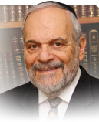

Our father Abraham experiences the revelation of the L-rd when he is sitting alone at the opening of his tent. Only a few days had passed since his circumcision and the day itself is being described. He appears to us as a solitary figure, wrapped in his own thoughts, searching for attachment to his Creator. We are accustomed to think of this situation as being one of preparation for the visit of the three angels. However, if we but take a broader view of the matter, we readily can see that the Torah is describing for us the permanent and regular state of being of our Father figure.

He constantly experiences the presence of the L-rd within and without. All his life, in everything that he does, is measured by the metric that the Lord is looking over his shoulder and recognizing the potential reward for his actions and goodness. King David centuries later said that he always envisions the presence of the Lord before him permanently. This is the highest level of attachment to the Creator that is humanly possible.

This emotional attachment is described for us in detail in many of the holy Psalms of King David. These depictions are based on the formative experiences of our father Abraham in founding the Jewish people. Wherever he goes and whatever he does, our father Abraham feels within himself that the Lord is appearing before him and accompanying him on his new and difficult journey through life.

Even in his moments of sleep and while dreaming, Abraham is constantly aware of, if not in fact interacting, with his Creator. The gift of prophecy is one of the highest forms of communication and attention to G-d. There were, in ancient times, schools that trained people to become prophets. I have often wondered how that is possible, since the service of prophecy seems to be a one-off moment of revelation bestowed upon certain human beings. So how can one go to school to become a prophet?

Upon deeper reflection, it is obvious that even if the moments of recorded prophecy are rare and few, part of the necessary attribute to become a prophet is that one constantly trains oneself to visualize Heaven and to attempt to maintain a constant attachment to one's eternal soul and Creator. And this required training includes study, effort, sacrifice, and the attainment of a special relationship with impunity and eternity.

So, the description of the Lord that begins this week's Torah reading should be viewed as a description of the constant and permanent state of the relationship between G-d and Abraham, and not merely as a one-time fortuitous experience of holiness. Perhaps, this is what the rabbis meant when they stated that the all-merciful One desires our hearts. G-d desires our permanent attention, goodness, and righteousness, and that we not be distracted by the vagaries of life. We must become a holy nation and a kingdom of priests

*Reprinted from the current website of rabbiwein.com*

*Reprinted from Reprinted from the 5756/1996 Vayeira edition of L’Chaim Weekly.*

**Learning from Avraham**

**How to be Mesiras Nefesh**

**In Helping Other Jews**

**From the Talks of the Lubavitcher Rebbe**

**Rabbi Menachem Mendel Schneerson, Zt”l**

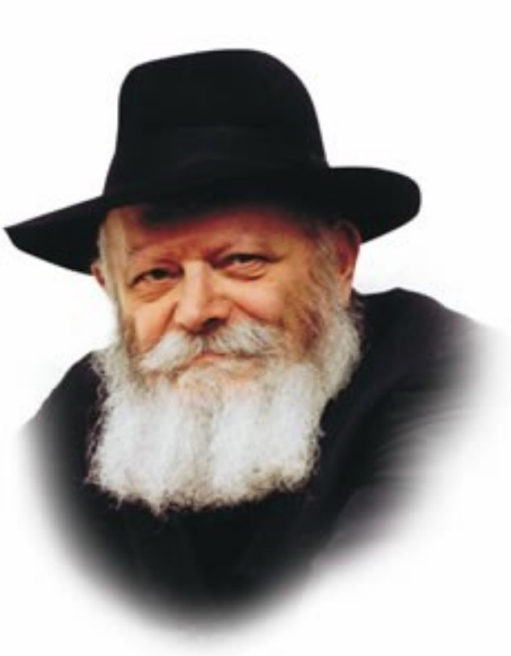

In this week's Torah portion, Vayeira, we read of Avraham's attempt to save the wicked city. When G-d told Avraham He was going to destroy the city of Sodom, Avraham tried everything he could think of to dissuade Him, as the Torah tells us, "And Avraham drew near and said, 'Will You then destroy the righteous with the wicked?'"

Rashi, the foremost Torah commentator, explains the meaning of this verse: "Avraham attempted all these methods: speaking harshly, appeasement, and prayer."

Avraham was willing to do anything in order to save the city of Sodom. His first approach was to "speak harshly" to G-d. When that wasn't effective, he tried to appease Him, and when that didn't work, he resorted to prayer and supplication. All possible means were attempted in Avraham's bid to persuade G-d to avert the decree.

Our Patriarch Avraham was referred to by G-d as "Avraham, the one who loves Me." How then could Avraham have had the audacity to address G-d harshly?

**Avraham’s Unusual Approach**

Also, why did Avraham begin his attempt to dissuade G-d from carrying out His plan with harsh words, rather than first trying to appease G-d in a more conciliatory manner, or with prayer? Wasn't Avraham characterized by his great kindness?

The key to understanding this lies in the fact that Avraham was faced with a matter involving the saving of lives. G-d had already issued His decree; the angels had already been dispatched to destroy the city. Thus, Avraham saw no other choice but to demand that G-d change His mind, even if harsh words were required.

At such a time, Avraham did not allow himself the luxury of taking personal considerations into account. No method of persuasion was off-limits or out of bounds. The only thing that mattered was that the city of Sodom not be destroyed, and Avraham tried with all his might to prevent it from happening. Speaking harshly to G-d was the antithesis of Avraham's nature; nonetheless, he did not refrain from doing so in the hope that it would bring about the desired effect of saving the city and its inhabitants.

**Learning from Avraham and Emulating His Ways**

We, the descendants of Avraham, must learn from his example and emulate his ways.

Whenever the saving of a Jewish life is involved, be it in the physical or spiritual sense, bringing him closer to Torah and mitzvot, we cannot stop to weigh our choices or to calculate our options. The thing to do is act, and to act immediately. All of our efforts, all of our strengths and energy must be used to that end, even if it is contrary to our nature and even if harsh words are required. For all methods are permissible when it comes to saving the life of a fellow Jew.

*Reprinted from Reprinted from the 5757/1996 Vayeira edition of L’Chaim Weekly. Adapted for Maayan Chai from Lijutei Sicho, vol. 10.*

**Rama Mi’Fano**

[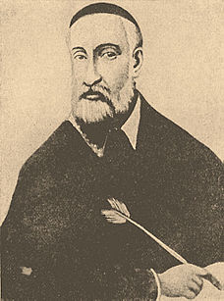](https://en.wikipedia.org/wiki/File:Brockhaus_and_Efron_Jewish_Encyclopedia_e10_839-0.jpg)

Rav Menachem Azaryah of Fano zatz'l [5307 (1547) - 4 Av 5380 (1620)] Rav Menachem Azaryah is known as the "Rama Mi'Fano" after his initials and his hometown. He was also known as Rav Emanuel. (He should not to be confused with "Rema"--Rav Moshe Isserles.)

Rama was a leading scholar and philanthropist in Italy.His teachers included Rav Yishmael Chananiah of Vallmontone and Rav Ezra of Fano. Rama used his great wealth to support the poor as well as to publish sefarim (Torah works).

Besides his own works, he was responsible for the publication of classic works including Rav Yosef Karo's Kessef Mishneh and some works of Rav Moshe Cordevero ("Remak"). Rama was accomplished in Talmud, halachah, and kabbalah. His best-known works are in the last of these fields.

Originally, he was a disciple (from a distance) of Remak. However, when Rav Yisrael Seruk, a disciple of Arizal, arrived in Italy in 5357 (1597), Rama became Rav Yisrael's student. Rama is credited with playing a decisive role in making Arizal's system of kabbalah study the predominant one.

Indeed, because Rav Yisrael Seruk was among the earliest students of Arizal, Rama's writings transmit teachings which are not found elsewhere. Rama's work Asarah Ma'amarot addresses the moral and ideological lessons of kabbalah, rather than its technical side. It also explains many verses and Talmudic statements. In Ma'amar Chikur Ha'din (II:28),

Rama observes that there is a difference between the term "nachalah" and "yerushah"--both of which mean "inheritance." The former word is related to "nachal"--stream--and is used repeatedly in parashat Pinchas (Bamidbor 26:54) when referring to inheritance which flows directly from a father to a son (just as a river flows continuously and directly). The latter term is used when referring to indirect inheritance, whether a son inheriting from a mother, a brother from a brother, or a daughter from a father.

The Torah says (Devarim 18:20),"Righteousness,righteousness shall you pursue, so that you will live and possess ('ve'yarashta') the Land that Hashem, your G-d, gives you." Rama writes that the Torah uses a form of the word "yerushah" (the less direct inheritance) here in order to teach that we should not feel certain about holding-on to Eretz Yisrael. Similarly, the Torah is called a "morashah" (Devarim 33:4) because a son cannot inherit it from his father. Torah must be acquired by each person independently. (Hamaayan)

*Reprinted from the Parshat Vayeira 5781 email of Reb Yedidye Hirtenfeld’s whY I Matter, the parshasheet of the Young Israel of Midwood in Brooklyn.*

**Thoughts that Count**

"*He looked and behold three men were standing over him*." (Gen. 18:2)

According to Midrash Rabba (48:9), the three men were angels who appeared as a desert merchant, a produce merchant, and a captain of a ship. The world is divided into three parts: water, desert, and inhabited land. Each part of the world has an angel appointed over it. Thus, the three disguised angels represented the entire creation. The one dressed as a desert merchant was for the deserts, the ship captain was for the oceans, and the produce merchant represented the inhabited part of the world.

On the passage, "These are the chronicles of heaven and earth when they were created," our Sages say, "Read not 'behibaram,' but read 'beAvraham.' " This alludes to the fact that the entire world was created for the sake of Avraham *(Rabbeinu Bachya).*

*Reprinted from Reprinted from the 5756/1996 Vayeira edition of L’Chaim Weekly.*